** STREAM:**

**Joy and Meaning**

we’d greatly appreciate your use of this qr code to record attendance for this HRSA funded program



**1. Why Focus on Meaning, 2. How to Focus on Meaning, 3. Stories of Meaning**

Listening sections, no need to write

**4. Reflecive Practice as a Tool**

PARTNER ACTIVITY: Reflect/Pair Share

**Question:**

As you look back on your life, try to recall key moments or events that helped you develop a deeper understanding of your purpose.  These might be influential teachers or readings, opportunities that were offered or denied to you, doors that opened or closed, decisions you made or did not make, tough challenges or exciting realizations.

**Take a few minutes to remember one of these moments.**

What happened?  How did the story unfold?

What did you learn about what has meaning for you?

LARGE GROUP DEBRIEF

**5. How to Continue this Work**

PARTNER ACTIVITY: Reflect

**Reflect on a moment of positive connection with someone recently**

Think about who you shared that moment with and what made it joyful.

What is one word that describes the feeling of that connection?

**6. Positive Impact of Joy**

INDIVIDUAL ACTIVITY: Reflection

**Reflect on a meaningful connection with a patient or colleague**

What were the joy moments of “mutual delight” you shared?

Why was it meaningful to you?

What allowed you to experience that connection at that time (e.g., setting, your frame of mind)?

DEBRIEF

**7. Continuing with Joy**

GROUP ACTIVITY: Making Space for Joy

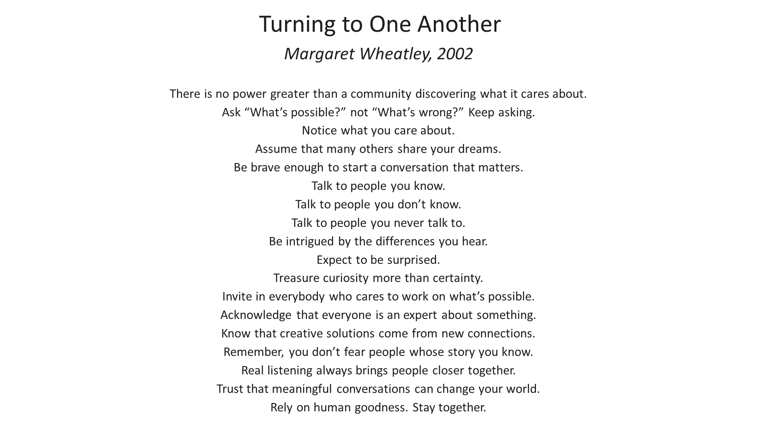

Thank You

We’re so glad you could be part of this program with us today. Thank you for your

participation! Please help us out by completing this 6 question evaluation today! We’d love your input re:

Content relevancy, DEI incorporation, interactiveness of session, facilitator effectiveness, likelihood to recommend, and an open ended section for anything you’d like to note.

You’ll receive a follow up survey in two weeks. We’d love your feedback!



Extra Resources Available to You

STREAM Resource Library

There are extra STREAM resources and activities available for your use on our site as well.  We have more videos, worksheets, and other links that you may find beneficial.  Check them out here:

note: these materials are available for anyone with a STREAM account



STREAM App

Download our app, available for free

Apple: Android:

 

Features

-Buddy chat (anonymous capability)

-Goal setting and tracking

-Journaling

-Links to extra STREAM resources on the app

-Opportunity to provide feedback for STREAM programming

Follow us on Twitter: STREAM@elms